MAKING WEAPONS

Today, we are going to implement three weapons:

- 1. A pipe that can knock down an enemy.
- 2. A gun that shoots bullets and deals Damage to an enemy.
- 3. A grenade launcher that shoots out grenades and deals Damage.

Let's analyze what parts of the three weapons can be generalized or, in other words, can be in a parent class.

1. Visual. They all need a physical representation or a model.
2. UI and icon. Most weapons need a UI and an icon. We can add an icon of each weapon to the lower right corner of the game to show the player what they have. For UI, we need crosshair for the gun and the grenade launcher.
3. They all attack in one way or another. It is an abstract idea that can be generalized.
4. Attack damage. Again, not all of them need it, but a general part that most weapons would have.
5. Reloading. Well, the pipe cannot reload, but an electric staff that shoots out lighting balls might need some sort of recharging. Reloading is also an abstract idea here. We assume that most weapons need to replenish at some point, and we choose to include this for the scalability of the game.
6. Animations. All animations needed for walking, idle, Attack, and Reloading need to be specified.
7. Attachment. We need to define how the player should hold these weapons.
8. Hotkey. We need a keyboard or gamepad short cut for each weapon.

Create a Base Weapon Class

Create a blueprint class.

- Create a new folder called Weapons in the Blueprints folder.

- Inside the folder, create a new blueprint class, pick Actor as its parent class, and name it BP_WeaponBase.

Add visual representation to the class.

- Open BP_WeaponBase, add a StaticMesh component to it, and name the component Mesh.

- Set the Static Mesh to a pipe or melee weapon model. I’m using this free car exhaust from the Fab store.

Set up the socket for the pipe.

- Open up the Skeletal Mesh for your character. Mine is named SKM_Ogre (You can see the skeletal mesh you’re using in the Details panel of your BP_CharacterFPS).

- Click on the Preview Animation in the toolbar at the top of the UI and choose your melee holding animation.

- I downloaded a sword-wielding idle animation from Mixamo.

- The mesh now plays the pipe idle animation. I named mine AS_PipeIdle. It doesn't matter if you see the full body mesh or the FPS mesh in the viewport because you can change the Preview Mesh to the other one if you wish.

- The animation is playing, click on the pause button at the bottom of the window to pause it.

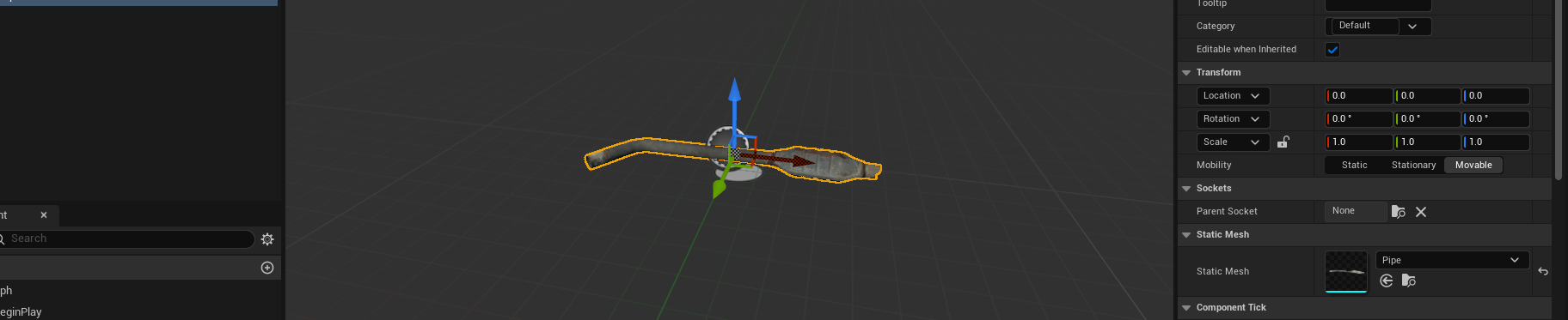
- In the Skeleton Tree list, find RightHand, right click on it, and select Add Socket.

- A new socket called RightHandSocket got added to the list, double click, and rename it to PipeHandSocket.

Socket

There are plenty of times you need to attach something to the character, and you can attach anything to any joint of the skeletal mesh. However, it is improbable that you want the attachment to be precisely where the joint is, but preferably with an offset.

- Right click on PipeHandSocket and select Add Preview Asset, search, and select your pipe static mesh.

- Go to the viewport, move, and rotate it to make the pipe fit into the hands nicely (as shown). Press the Save button to save the changes.

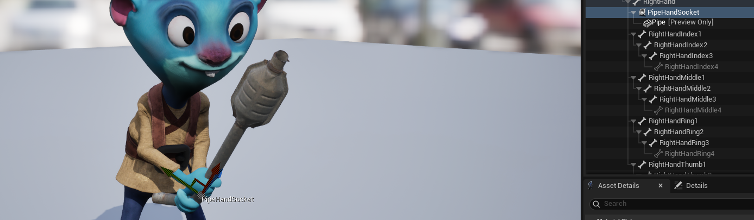

Add a socket for the hands.

- Add an attachment variable. Go back to BP_WeaponBase.

- Add a new variable and name it EquipSocketName.

- Make the Variable Type Name, compile it, and set the Default value to PipeHandSocket. We add this variable, so the weapon can always refer to it to find the correct attachment. (It must match the name of your socket).

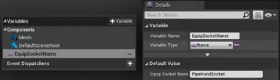

Create a method for the character to acquire a new weapon.

- Go back to BP_CharacterBase. Add a new custom event (right click and search for add custom event), and name it AcquireNewWeapon.

- Go to the Details panel and add a new input parameter to it.

- Name the new parameter WeaponClass and change its type to BP_WeaponBase; make sure that you choose Class Reference.

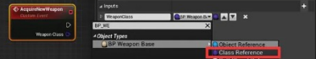

By choosing a class reference, we are taking in a class instead of an object of a class. We can now use this class to spawn a weapon.
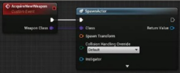
- Create a “Spawn Actor from Class” (right click and search) node.

- Connect the out execution pin of AcquireNewWeapon to the in execution pin of the Spawn Actor NONE node to call it with AcquireNewWeapon.

- Connect the Weapon Class pin of AcquireNewWeapon to the Class input pin of the Spawn Actor NONE node.

For the Spawn Transform, we can use the transform of the socket.

- Hold down Ctrl and drag the Mesh from the Components panel to the graph to create a reference for it.

- Drag out from the pin of the new Mesh node, search, and create a Get Socket Transform node.

- Connect the Return Value of the Get Socket Transform node to the Spawn Transform input pin of the SpawnActor node.

- For the In Socket Name, drag out from the Weapon Class pin of the AcquireNewWeapon, search, and create a Get Class Defaults node.

- Drag the Equip Socket Name pin of the Get Class Defaults node to the In Socket Name of the Get Socket Transform node.

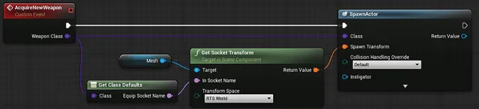

Copy BP here

This piece of code spawns a BP_WeaponBase at the socket of the weapon.

Click the expansion arrow at the bottom of the SpawnActor node, and you can see that we can specify an owner and an instigator for this new weapon.

Instigator

Instigator is another handy member variable of the actor class, and it should store the logical instigator of the damage or other events this Actor causes. The Owner and instigator of an actor could be the same thing, and they usually are. However, consider a grenade or a grenade launcher; logically, the grenade launcher is the Owner of the grenade, but the instigator should be the player who is holding the grenade launcher. After all, it is the player who pulls the trigger.

- Right click in an empty area and search for “self", in the drop-down list, select Get a reference to self.

- Connect this new Self node to the Owner and Instigator input pin of the SpawnActor node.

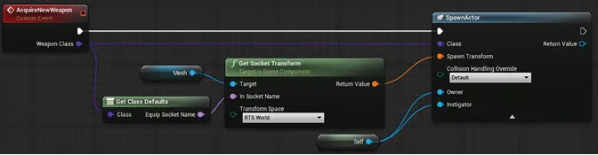

- Finally, create an AttachActorToComponent node, and call it with the SpawnActor node.

- Use the return value of the Spawn actor node as the Target, use the Mesh as the Parent, and use the Equip Socket Name of the Get Class Defaults node as the Socket name.

- Set the Location, Rotation, and Scale rules to Snap to Target. Notice that the line connecting from the Equip Socket Name of the Get Class Defaults node to the Socket Name of the AttachActorToComponent node is too long. The line is also overlapping the nodes in the middle.

- Double click anywhere on the line to create a reroute node, and move the reroute node to make the line go around other nodes.

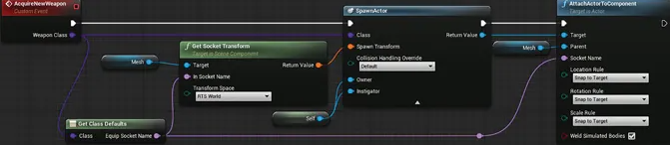

Copy entire updated AcquireNewWep BP here

Why?

We implemented this function or event in the BP_CharacterBase class instead of the BP_CharacterFPS. The reason is primarily for the scalability of the game. We can create AI characters based on BP_CharacterBase as well, and the AI should have the ability to acquire a weapon right away.

As you have gotten familiar with blueprint scripting, from now on, let's omit trivial details of the creation and connection of the nodes to save time.

Test our function.

- Zoom out of the graph, find the Event BeginPlay event, and call our AcquireNewWeapon function with Event BeginPlay.

- Play the game and you should see the character now holding the pipe.

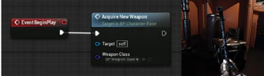
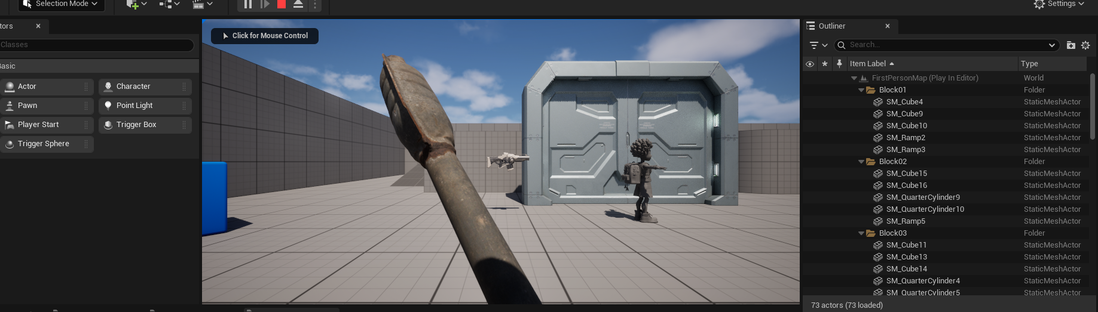

There are two flaws here. First of all, try to move around, and you will have a hard time moving forward. This is because the pipe is colliding with you. Secondly, the animations are for the gun and not the pipe. Let's address these two issues.

Fix the weapon collision.

- Open BP_WeaponBase and select the Mesh in the Components panel. In the Details panel, find the Collision section and set Collision Presets to NoCollision.

- Play the game again and you should be able to move freely.

Add animation variables to the weapon class.

- Add two more variables to BP_WeaponBase, and set their variable type to Anim Sequence object reference.

- Name the first one IdleAnim, and set its default value to AS_PipeIdle (or whatever your idle pipe animation is). Name the second one WalkAnim and set its default value to AS_PipeWalk.

Let's create a variable to store the current active weapon and implement a function that can spit out the idle and walk animation of that weapon.

Create a current active weapon variable.

- Go back to BP_CharacterBase and add a new variable.

- Name the new variable CurrentActiveWeapon and set the variable type to BP_WeaponBase object reference.

- Go to the AcquireNewWeapon, break the connections between the SpawnActor node and the AttachActorToComponent node, and insert a Set Current Active Weapon Node in-between.

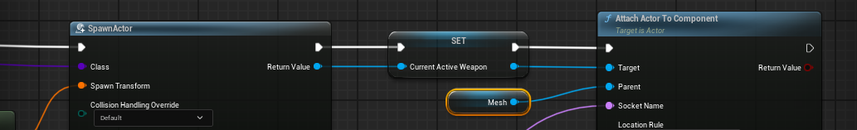

Create a function to get the animations from the current active weapon.

- Add a new function to BP_CharacterBase and call it GetActiveWeaponAnims. Implement it as shown below.

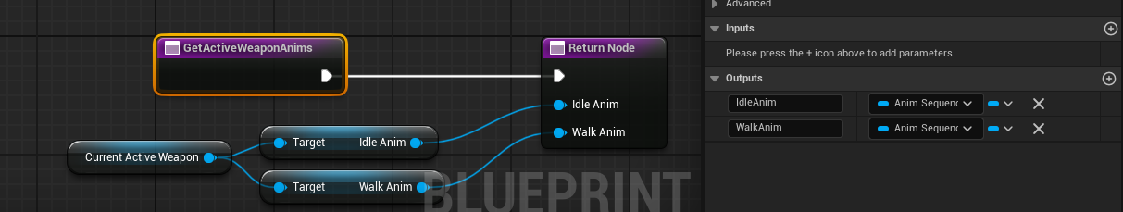

Copy BP here

Call the function in the animation blueprint to update the animations.

- Go to Content/Blueprints/Animations and open ABP_Character.

- Go to the My Blueprint panel and double click the EventGraph under the Graphs section to go to its event graph. After the SET node, add the blueprint script shown in the image below.

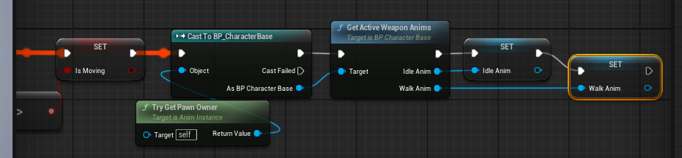

By using the Try Get Pawn Owner function, we can get the pawn that this blueprint is attached to. In our case, the Owner is our BP_Character_Base, so we cast it to BP_Character_Base to get access to the GetActiveWeaponAnims function.

If you think about it now, there are two design flaws in our current set up:

1. What if the player hasn't picked any weapon yet? We do want the player to have no weapons at the beginning of the game and will pick up new weapons while exploring the level.
2. We do not need the animations to be updated every time the game updates; we only need to change them when the player picks up or switches to a different weapon.

Animation

Set up a weapon switch animation.

- Make sure that you save your blueprints. Close and reopen SKM_Ogre, or whatever your character’s skeletal mesh is, so that no preview animation is used.

- Go to the toolbar at the top of the window, and click Create Asset → Create Animation → Current Pose.

- Select the Animations folder in the pop-up window, and set the Animation Name to AS_WeaponSwitch. Unreal now creates a new animation, and we can see it in the list of the Asset Browser at the lower right corner of the window.

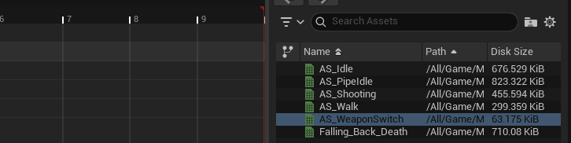

So far, this new animation we added has one frame, as indicated at the bottom of the timeline.

- Right click anywhere on the timeline and select Append in the beginning.

- Type in 9 for the Number of Frames to Append and hit Enter. We now have ten frames in total.

- Click the Pause button at the bottom left corner of the timeline to pause the animation playback

- In the Skeleton Tree panel, select Spine2. Rotate it to bend the body forward in the viewport (about 60 degrees) and press the S key on the keyboard to add a key. It doesn't matter on which frame we added the key because we only need a fixed bend down pose.

- Click the Apply button in the toolbar to commit the changes.

- Go to the Asset Details panel (it is shuffled with the Skeleton Tree panel). Under the Additive Settings section, set the Additive Anim Type to Local Space. This animation now becomes an animation that will be added on top of other animations when used.

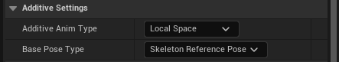

- The Base Pose Type is Skeleton Reference. This setting means that it calculates the difference between the poses in this animation with the default skeleton pose in local space and extracts the delta as the additive or offset information (as shown).

- Press the Save button to save the asset.

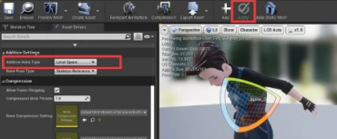

Create the weapon switch animation montage.

- Click the Create Asset again and select Anim Montage. Name it ASM_WeaponSwitch and hit ok. Unreal now has created an animation montage for us and opened it in Persona. Notice that it shows with a blue icon in the Asset Browser.

- Go to the Asset browser, find, and drag AS_WeaponSwitch to the DefaultGroup.DefaultSlot row of the timeline (as shown).

- Press the Save button to save the asset.

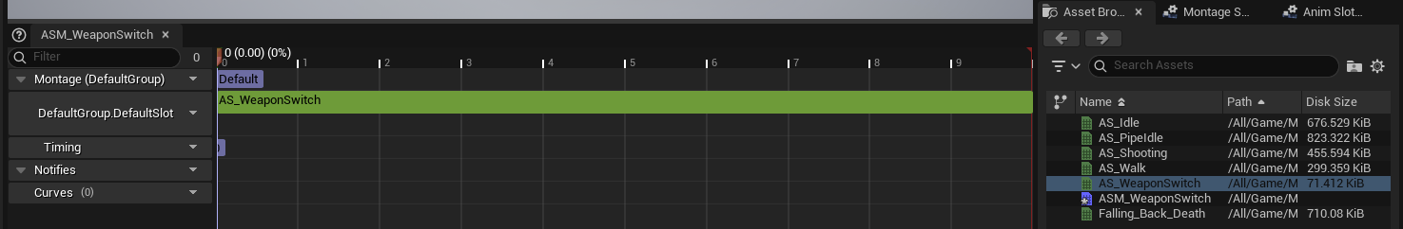

- Go to the Asset Details panel. Open the Blend In and Blend Out sections in the Blend Options section.

- Set both Blend Time settings to 0.15. This makes the animation blend in and out in 0.15 seconds.

Add the DefaultSlot.

- Click the Blueprint button at the top right corner of the window to switch to our animation blueprint.

- Double click the AnimGraph in the My Blueprint panel to open the animation graph.

- Create a Slot 'Default Slot 'node and insert it in-between IdleWalk and the Output Pose (as shown).

- Compile and save the animation blueprint. Remember, you can Alt-click on any pin to delete the connections to it.

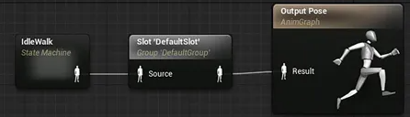

Add a custom event to play the animation montage.

- Go back to BP_CharacterBase. Create a new custom event called SwitchActiveWeaponTo and implement it as shown. The Montage to Play is set to ASM_WeaponSwitchMontage.

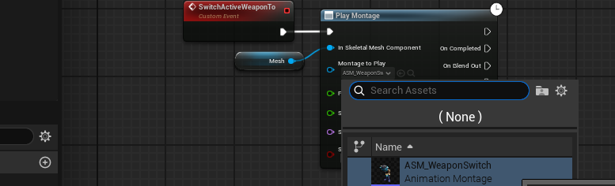

We will add more stuff to this function, so it does what the name says. For now, we are just testing the animation montage.

Test the animation Montage with the fire button.

- Create an EnhancedInputAction Shoot node and call the SwitchActiveWeaponTo with InputActionFire.

- You will likely have to go to your IMC_Default in the ThirdPerson folder to assign the Shoot button to left-click.

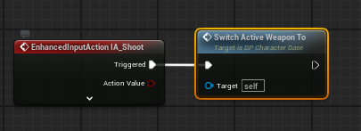

- Play the game again, try left clicking, and you can see the hands go down and back up again.

What’s happening?

- When we press the left mouse button, the system triggers the fire event (defined in the input bindings). The fire event calls the SwitchActiveWeaponTo event, which asks the Mesh to play the ASM_WeaponSwitchMontage animation montage.

- ASM_WeaponSwitchMontage is assigned with the DefaultGroup.DefaultSlot, and the Mesh finds that slot in the AnimGraph of the animation blueprint and plays the animation montage there.

- The animation in the montage (AS_WeaponSwitch) is additive. So, the montage adds on top of the current AS_PipeIdle animation to bend the body down.

- The body then bends down smoothly in 0.15 seconds and bends back up after the animation is over (in 0.15 seconds as well).

As you can see, the whole system works in a somewhat complicated way. This is the nature of the Unreal Engine. It is not an easy engine, like what we have covered before; Unreal values professionalism and scalability more than simplicity.

Custom Event

Create a WeaponInInventory and a WeaponInHand custom event.

- Open BP_WeaponBase and quickly implement a WeaponInInventory and a WeaponInHand custom event as shown

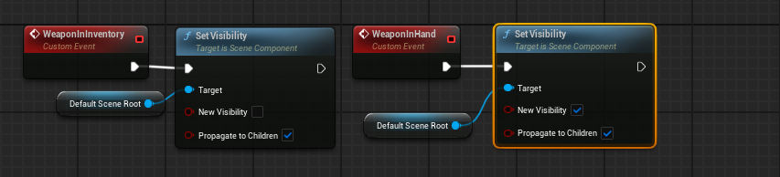

Copy BP here

The Set Visibility function sets the visibility of the Target input. Make sure that you drag the DefaultSceneRoot from the Components to the Target and check on Propagate to Children so everything will be toggled.

Use the WeaponInInventory function in the AcquireNewWeapon functions.

- Go back to the AcquireNewWeapon function of BP_CharacterBase and delete the Set node between SpawnActor and AttachActor ToComponent.

- Drag out from the Return Value of the SpawnActor node, search, and create a call to Weapon in Inventory as shown.

- Make sure that you still call the AttachActorToComponent eventually.

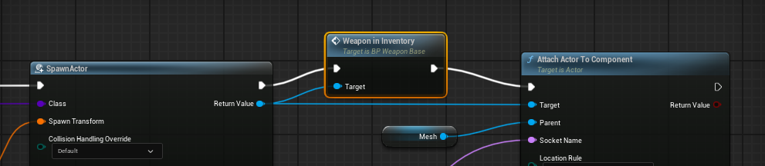

Copy entire updated AcquireNewWep BP here

What we have changed here is when we get a new weapon:

- We put it in the inventory first (which makes it invisible).

- After this step, we then have to play the weapon switch animation montage to put the hands down.

- Then we make the weapon visible (by calling WeaponInHand) and tell the animation blueprint to update to the new animations, and then the hands go back up. We can put these parts in the SwitchActiveWeaponTo event.

Refine SwitchActiveWeaponTo.

- Add a new Input parameter to the SwitchActiveWeaponTo and name the parameter NewActiveWeapon, and make the variable-type BP_WeaponBase.

- Drag out from the New Active Weapon of the SwitchActiveWeaponTo and select Promote to variable. A new variable got automatically added, and a Set node got created as well. This is a quick way to make a new variable and set its value. We will not mention steps like this anymore.

- When you see a Set node like this with a variable name you haven't seen before please assume that we created a new variable with the Promote to variable command.

- Name the new variable PendingNextActiveWeapon, and the Set node automatically changes. Connect the Set node.

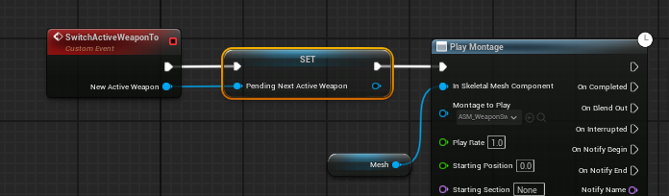

Copy BP here

While we are at it, let's also add a call to SwitchActiveWeaponTo at the End of the AcquireNewWeapon event.

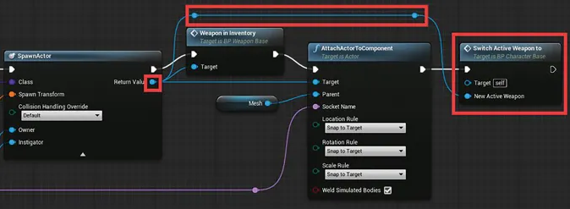

Notice that we added two reroute nodes between the Return Value (the spawned new weapon) and the New Active Weapon input parameter of the SwitchActiveWeaponTo node. You can create a reroute node, just like how you create other nodes (right click and search). What we are doing here is after acquiring a new weapon, we want to switch to it right away.

Notifies

Add an animation notify.

- Go to Blueprints/Characters/Animations/ and find ASM_WeaponSwitch.

- Double click to open it, and press the space bar to pause the animation playback. There are multiple sections of the timeline listed at the left side column. The Montage section has our AS_WeaponSwitch animation, and this is the part where you populate animation assets for the montage.

- The Notifies section underneath is where we can add animation notifies, and there is currently one track named “1” in it. Right click anywhere of that one track in the timeline and select Add Notify → New Notify.

- In the pop-up Notify Name, type in WeaponSwitchHandDown as its name and press Enter to add it.

- A diamond-shaped point with a WeaponSwitchHandDown sticker got place in the timeline; drag it to reposition it around frame 5

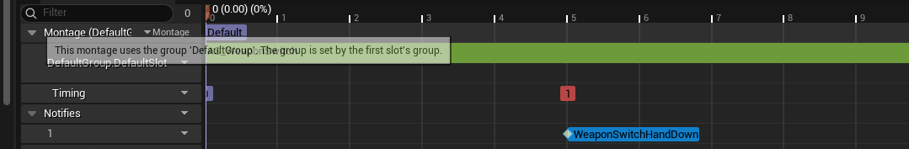

Add an AnimNotify event.

- Go to the event graph of the animation blueprint (you can switch to different graphs by double clicking them in the My Blueprint panel).

- Right click in the graph and search for WeaponSwitchHandDown, and there should be only one option called Event AnimNotify_WeaponSwitchHandDown.
TIP: If the node isn’t showing up, your ABP may be using a different skeleton than your animation. You can change the skeleton of an ABP by going to the Class Settings > Advanced > Target Skeleton.

- Click on it to add it to the graph. This event runs when the notify is hit in the timeline. Let's print out a “Hands are down” message with it using the print function

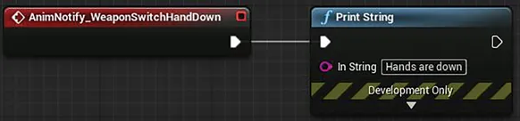

Play the game now, and you can see that the message got printed, and every time you left click, the message will be printed after five frames because that is when the notify is hit in the timeline.

Create a function to set up the active weapon.

- Go back to BP_CharacterBase. Create a function called WeaponSwitchHandsDownNotify.

- Add a Sequence node, and press the Add pin label of the Sequence node to add another pin.

- Construct the rest of the function as shown.

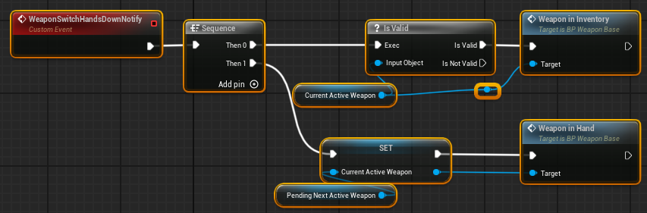

Copy BP here

This WeaponSwitchHandsDownNotify event does two things:

- First of all, it checks if there is a CurrentActiveWeapon by passing it through an Is Valid node, and then calls its WeaponInInventory event to hide it.

- Second, it sets the CurrentActiveWeapon variable to be the PendingNextActive Weapon we set up in the SwitchActiveWeaponTo event. This should set the value of the CurrentActiveWeapon to the new weapon we acquired. It then calls the WeaponInHand function to

Call WeaponSwitchHandsDownNotify in the animation blueprint.

- Go back to the animation blueprint.

- Remove the print node and reconstruct the AnimNotify_WeaponSwitchHandDown event as shown.

- Delete all the nodes after the Set Is Moving node in the Event Blueprint Update Animation event.

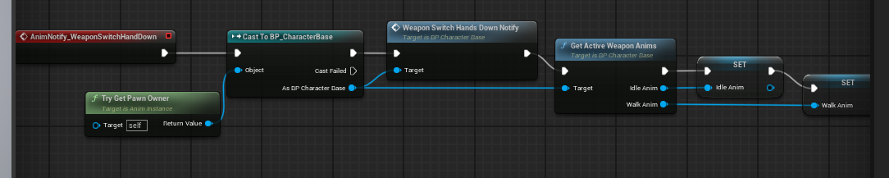

Copy BP here

- To be able to see the result, go to BP_CharacterBase and insert a Delay node between Event BeginPlay and Acquire New Weapon.

- Set the Duration of the Delay node to 2.0 (as shown). This Delay node adds a 2-second delay before calling the Acquire New Weapon event.

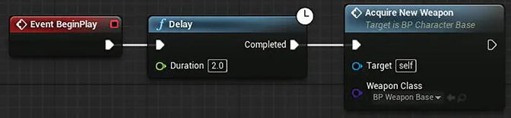

Play the game again and now you can see that we start with the gun idle animation. After 2 seconds, the hands go down and come back again with the pipe. The animation is also switched correctly.

Remove the gun animations.

- We should not be playing the animations of the gun at the beginning of the game.

- Go to the Animation blueprint, and select the IdleAnim variable in the Variables section.

- Go to the Details panel, click the drop-down of the default value of the IdleAnim, and select clear to make it empty. When it's empty, the default pose is used. You can also delete the InputAction Fire event. It is only created for testing.

Play the game one more time, and the player should now start with no animations. After 2 seconds, the player's character pulls out a pipe.

We are not entirely done with this part yet. We will revisit it after we have more than one weapon. Meanwhile, let's move on to add the attack animation.

Animation Montage for Pipe
Create the Attack animation montage.

- Go to your Animations folder and insert an AS_PipeAttack animation. This animation is the Attack animation of the pipe. I used the Great Sword Slash animation from Mixamo.

- Right click on it and select Create → Create AnimMontage.

- An animation montage was created in the same folder; name it ASM_PipeAttack.

- Open BP_WeaponBase, select the WalkAnim variable, press Ctrl + D to duplicate it, and name it AttackAnim.

- Change the variable type of AttackAnim to Anim Montage object reference. Compile and save the blueprint and then set the default value of AttackAnim to ASM_PipeAttack.

Create an event to play the attack animation montage.

- Create a PlayAttackAnim event for BP_WeaponBase as shown.

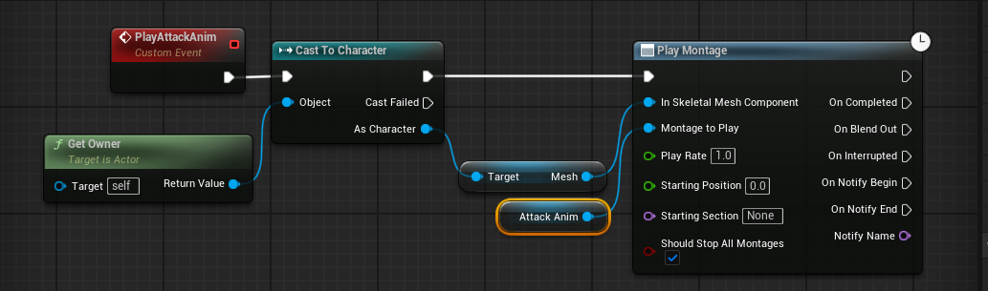

Copy BP here

This PlayAttackAnim event does what the name says: play the attack animation montage.

Refactor the part to get the Mesh component into a function.

- We will need to get the Mesh component in other places of BP_WeaponBase. Let's refactor this part of the code into a function to clean up our code.

- With the Get Owner, Cast To Character, and Target Mesh selected, right click on any one of them and select Collapse to Function. A new function was created that has all three nodes inside.

- Go to the My Blueprint panel, select the NewFunction, press F2, and rename it to GetPawnSkeletalMesh.

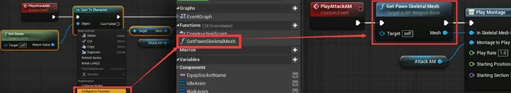

Make the function blueprint pure.

- Select GetPawnSkeletalMesh in the My Blueprint panel.

- Go to the Details panel and check on the Pure checkbox. The function is now a pure function. Pure functions do not have execution pins; they are called when their return values are used.

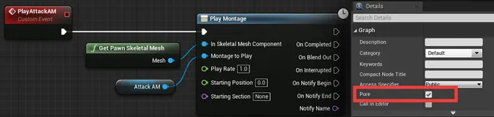

Make an empty CommitAttackAnimNotify event.

- We want to do the real attacking things like deal damage or launch a grenade at some point in the animation. The event doesn't necessarily happen at the beginning of the animation. We can use animation notify to inform the weapon at the time we really want to do the attacking things.

- Create a new custom event called CommitAttackAnimNotify and leave it empty.

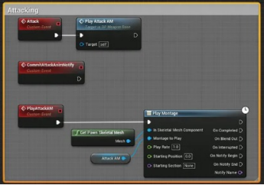
Create the Attack event.

- Create a new custom event and call it Attack.

- Call PlayAttackAnim with it.

- Drag a big marquee selection box to select all the nodes of the Attack, the CommitAttackAnimNotify, and the PlayAttackAnim event.

- Press the C button on the keyboard to make a comment box. Type in Attacking to rename the box to Attacking.

Copy BP here

Set up the attack input.

- Go to BP_CharacterFPS. Add the InputAction Fire event here, and implement it as shown. You will have to drag out from the IsValid node to get the variable, and drag out from the variable to get the Attack node.

- Play the game again, and you can now left click to attack after the player character gets the pipe.

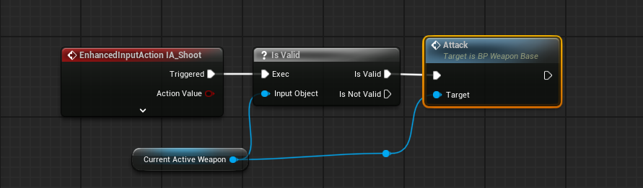

Copy BP here

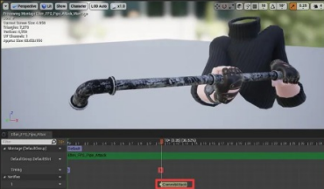
Fire the CommitAttackAnimNotify with an animation notify.

- Open ASM_PipeAttack and add an animation notify at the time that the pipe attack animation seems to be about to hit something.

- Call this new notify CommitAttack.

Go to the animation blueprint and implement the notify event as shown below.

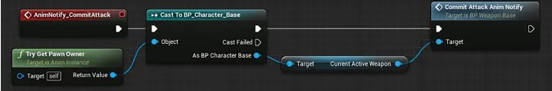

Copy BP here

What is happening now is when we left click, the player character calls the attack function of the active weapon, and it then plays the animation montage. When the montage hits the CommitAttack animation notify, it calls the CommitAttackAnimNotify event of the active weapon.

Weapon Classes

Make a BP_Pipe, a BP_Gun, and a BP_GrenadeLauncher class.

- Right click on BP_WeaponBase and select create child class, and name the new class BP_Pipe.

- Create two more classes the same way, name one of them BP_Gun and another one BP_GrenadeLauncher.

- Open BP_Gun and change the Static Mesh setting of the Mesh component to a gun mesh. Open the Fab store from the window tab to quickly find a free mesh, like this for example (just search “SCIFI SCG Gun Sketch” in the Fab window and set it to “Free” options). The FP default package also comes with a pistol.

- Also find a gun clip and bullet model. For quickness, I’ll be creating and using a black rectangle for the clip, but you can also find one on Fab and separate it from the gun using Blender. Or you can just use the bullet mesh for the clip as well, we’re doing this for learning purposes, not to make a perfect game.

- Search Fab to find a free grenade launcher like this one. (You can just search “Lost Hope Launcher” and check the “Free” box, in your Fab window).

- Change the static meshes of your BP_Gun and BP_GrenadeLauncher in the Components to add them, and don't forget to set their collision presets to NoCollison as well.

- You may have to change the scale so that they’re relative to the pipe (You will have to do this for the SM_GrenadeLauncher).

  - To change the scale of a Static Mesh in Unreal, drag it from the Content Browser onto your level. In the top right, change from “Selection Mode” to “Modeling Mode”.

  - Change the scale in Modeling Mode by selecting the “Transform” option (I had to use 0.00001 for X, Y, and Z) and bake the transform by clicking the “Bake Transform” option and confirming.

- Make sure you’re doing this in the level, not in the blueprint viewport or the static mesh tab. That way, it will spread across all instances.

- Open BP_GrenadeLauncher and just change the Mesh to SM_GrenadeLauncher. If you used the same launcher as me, you’ll have to scale it by 0.0001 in Modeling Mode and bake the transform. Below shows the hierarchy of the classes and the setting of the gun and the grenade launcher.

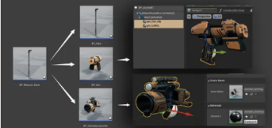

Set up the socket and Attack montage of the gun.

- Set up the socket for the gun the same way we set up the pipe and name it GunHandSocket. We do this because the gun will likely need to be repositioned a little bit, so we can’t just re-use the PipeHandSocket.

- If you recall, it’s just opening your Skeletal Mesh and adding a socket to the right hand bone, and then previewing the gun asset and repositioning so it looks correct.

- If the pipe is in the way of your preview, right click the PipeHandSocket and select Remove All Attached Assets

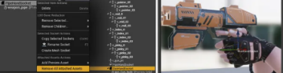

- Create the attack animation montage of the gun the same way we created ASM_PipeAttack. There’s a shooting animation on Mixamo (choose the one in the pistol pose).

- Name it ASM_Shooting.

- Open the animation montage (ASM_Shooting) and we’re going to create an animation notify on the frame we want the bullet to come out.

- However, when you create the animation notify, instead of adding a new one, you can find the CommitAttack in Add Notify → Skeleton Notifies → CommitAttack

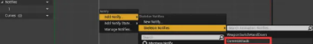

Populate the variables of BP_Gun.

- Open BP_Gun.

- Select the BP_Gun(self) in the Components panel.

- In the Details panel, change the Equip Socket Name to GunHandSocket.

- Set the Idle Anim, Walk Anim, and Attack Anim to the ones of the gun.

Set up BP_GrenadeLauncher.

- Add the socket and animation montage for the grenade launcher and set up BP_GrenadeLauncher the same way we set up BP_Gun.

- I made a new socket on the right hand and called it LauncherHandSocket. Then added a preview asset and adjusted its position.

- And then just made sure the name of the socket matched the name of the EquipSocketName parameter in the BP_GrenadeLauncher.

Test the three weapons.

- Open BP_CharacterBase and find Event BeginPlay.

- Change the Weapon Class of the Acquire New Weapon function call in the Event BeginPlay to BP_Pipe, BP_Gun, or BP_GrenadeLauncher.

- Play the game again and you can see all three of them work as expected. After creating the base class, we can quickly create child classes, and they should work with minimal setup.

When we have a class that is inheriting a parent class, we can also say that the class is derived from the parent class. In this case, all three weapons are derived from BP_Weapon_Base. If we ever need another weapon, we create another child class of the BP_Weapon_Base.

Weapon Attack Cooldowns

Create a weapon state enumeration.

- Go to the weapons folder, right click, and select Blueprints → Enumeration. A new enumeration asset was created; name it EWeaponState.

Enumeration

When programming, sometimes, we want to describe a list of possible selections or status that each one of them is unique. In the case of our weapons, all weapons could have three states: Idle, Attacking, and Reloading. Enumeration (or enum in short) is a built-in variable type that’s designed precisely for situations like this.

- Double click to open EWeaponState.

- Click on the Add Numerator button at the upper right corner of the window three times to create three entries. Change their display name to Idle, Attacking, and Reloading.

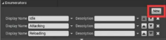

Add a EWeaponState variable to BP_WeaponBase.

- Add a new variable called WeaponState to BP_WeaponBase, and set the variable type to EWeaponSate.

- Compile and save the blueprint, and you can see that the default value is Idle.

- Click on the Idle, and we can see a dropdown list with three options: Idle, Attacking, and Reloading. You can only select one of the options in the drop-down list.

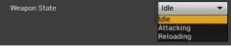

Create an animation notify state for the attack cooldown.

- Right click in the empty area of the Weapons folder and select Blueprint Class.

- In the pop-up Pick Parent Class window, type in AnimNotifyState in the search bar under the All Classes section.

- Select AnimNotifyState in the search results, and hit the Enter button to create an AnimNotifyState. This process is how we create a class inherited from any other existing classes. Next time when we do this, we will just say create a class derived from some thing.

- Name the new blueprint ANS_WeaponAttack.

Set up the animation notify state in the animation montages.

- Open ASM_PipeAttack. Hover the cursor over the “1” label of the notify track under the Notifies section in the timeline.

- Click on it and wait for a second, and you can then rename this track. Let’s name it Attacking.

- Right click on an empty area of the Attacking track and select Add Notify State → ANS_WeaponAttack. A new notify was added to the track, and this time, it has two diamond pins.

- Drag the left pin to the beginning of the track.

- Drag the other pin so that the range between the two pins covers the time that the weapon is on cooldown and cannot attack again.

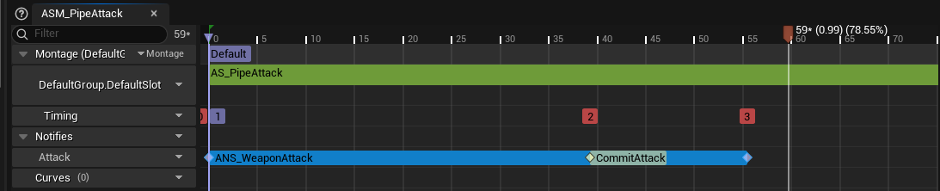

Go ahead and add ANS_WeaponAttack to the attack animation montage of the gun and the grenade launcher as well.

You could argue that we can attack again only when the animation is finished. But in reality, the waiting time is too long, and the player will feel frustrated by the attacking rate. It’s very common in many games to allow the player to attack again before the attack animation reaches the end.
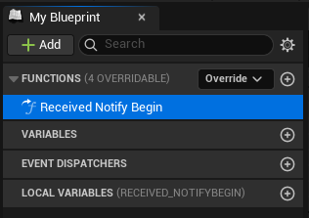
Implement ANS_WeaponAttack.

- Open ANS_WeaponAttack.

- Go to the My Blueprint panel, hover the cursor on the Functions section, and click Override → Received Notify Begin. A new function called Received_NotifyBegin got added to the Functions, and it is also opened for us.

This function is called when the animation hits the left pin of the animation notify state.

- Go to your BP_WeaponBase and create a new variable named WeaponState. Change the type to the Weapon State enumeration that we made.

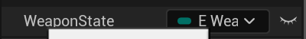

- Return to ANS_WeaponAttack implement the code below:

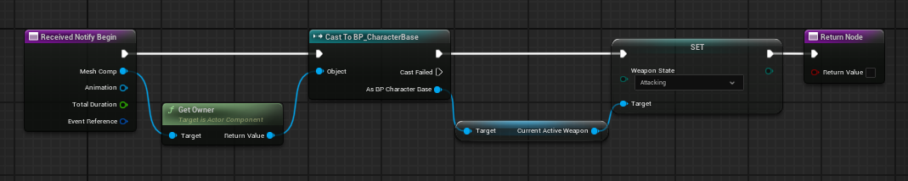

Copy BP Here

To create the Set node, drag out from the Current Active Weapon and search for set weapon state.

Go to the Functions section again, override the Received Notify End function, and implement it as shown below.

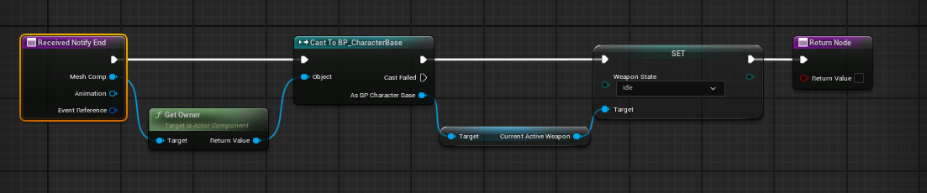

Copy BP here

Create a CanAttack function.

- Add a new function to BP_WeaponBase, and name it CanAttack. Implement it as shown below.

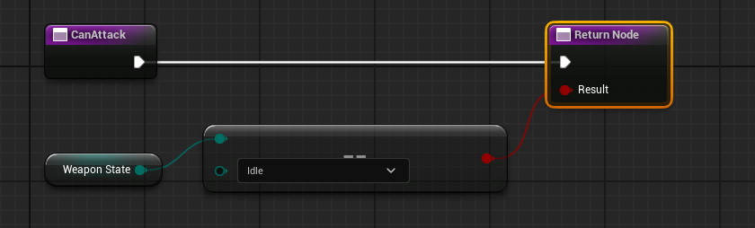

Copy BP here

The node that the WeaponState variable is connected to is an Equal node; to create it, drag out from WeaponSate and type in Equal and choose Equal (Enum).

The Return node was created normally, and I added a Result output Boolean.

- Insert a CanAttack call in the Attack event.

- Double click the EventGraph under the My Blueprint panel to go back to the EventGraph.

- Modify the Attack event as shown below.

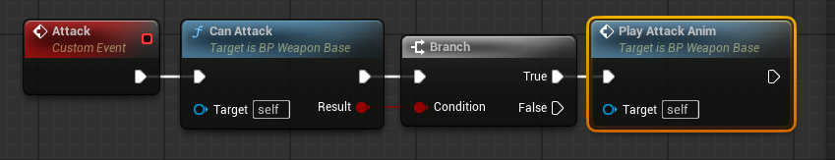

Copy BP here

What we did here is to check if we can attack and only attack if we can. Play the game again, and now we have proper weapon cooldowns. Again, all three weapons should work.

Weapon Damage

Pipe damage.

- Open BP_Pipe, go to Functions and override the Commit Attack Anim Notify function; if you do recall, this function is called when the animation hits the CommitAttack animation notify.

- Let’s go step by step to implement this function as shown below.

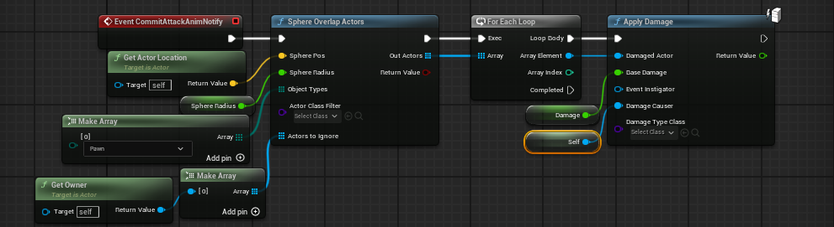

Copy BP here

- Create a SphereOverlapActors function node and call it using Event Commit Attack Anim Notify.

- Create a GetActorLocation for the Sphere Pos input of the SphereOverlapActors node. The GetActorLocation returns the location of the Target. Self means the actor of this blueprint, or in other words, the pipe.

- Drag out from the Sphere Radius input pin of the SphereOverlapActors node and select Promote to variable. A new variable was added to the blueprint, name it DamageRange, compile, and set the default value to 100.

- Drag out from the Object types and search and create a Make Array node. This node makes an array(list) of items.

- And now, it has only one item: item 0. Set the Item 0 from WorldStatic to Pawn. We only want it to overlay with pawns and ignore other types.

This SphereOverlapActors needs an array of Object Types because it needs to know what kind of object types you want it to overlap with, and it can be multiple types.

- Drag out from the Actors to ignore and create another Make Array node.

- Create a GetOwner node and connect it to the [0] input pin of the Make Array node. Again, the SphereOverlapActors needs to know an array of actors you want it to ignore. We only want to ignore the owner of the pipe, but you can add more if needed by clicking the Add pin button. You know that the Out Actors return value of the SphereOverlapActors node is also an array because its icon is a grid.

- Drag out from the Out Actors and create a For Each Loop node.

Loop

Whenever you want to do something multiple times, you can use a loop. This For Each Loop loops through every element of its Array input.

- Connect the Loop Body with an Apply Damage node.

- Connect the Array Element to Damaged Actor, drag out from the Base Damage input pin, and promote a variable to connect to it.

- Name the variable Damage and set the value to 100.

- Finally, connect a Self node to the Damage Causer because the pipe itself is the causer of the damage.

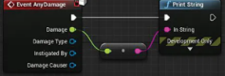
Test the attack of the pipe.

- Open BP_CharacterBase, search, and create an Event AnyDamage. This isn’t a Custom Event, just search for this node.

- Call Print String with Event AnyDamage, and connect the Damage output pin to the In String of the Print String.

- Set the Weapon Class of the AcquireNewWeapon function call in the Event BeginPlay to BP_Pipe.

- Drag a BP_CharacterBase to the level and play the game.

- After getting the pipe in hand, let’s get close to the BP_CharacterBase, press the left mouse button to attack, and we should see 100.0 was printed.

Gun Attack Line Tracing.

- Open BP_Gun and create an override to Commit Attack Anim Notify. Implement it as shown below.

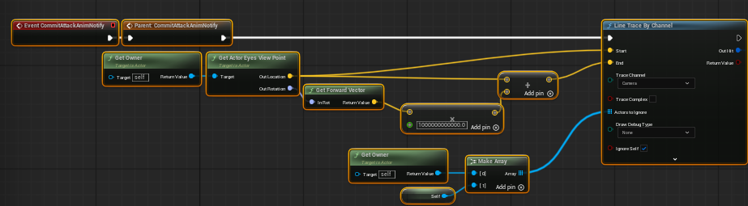

Copy BP here

The LineTraceByChannel traces a line between the Start and the End input. It returns an Out Hit, which contains the trace result. The owner here again is the BP_CharacterBase that owns this gun.

You can create that multiply node by dragging out from the Return Value of the Get Forward Vector, type an “*” in the search bar, and choose the Multiply node. You’ll have to right-click and convert the pin to a float, and insert a very large number or else it won’t work.

One last thing you probably didn’t notice here is that the Trace Channel is set to Camera. There are many prebuilt channels in Unreal Engine. An actor can choose to respond to any channel in three different ways: ignore, overlap, or block. The line trace only traces actors that block the channel it is tracing.

- Open BP_CharacterBase and select the CapsuleComponent in the Components panel.

- Go to the Details panel and find the Collision section.

- Expand the Collision Presets to view the collision responses. You can see that it chose to ignore the Visibility channel.

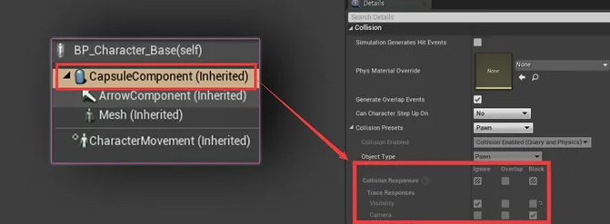

Apply Damage.

- On the other side of the LineTraceByChannel, we just simply do an Apply Damage.

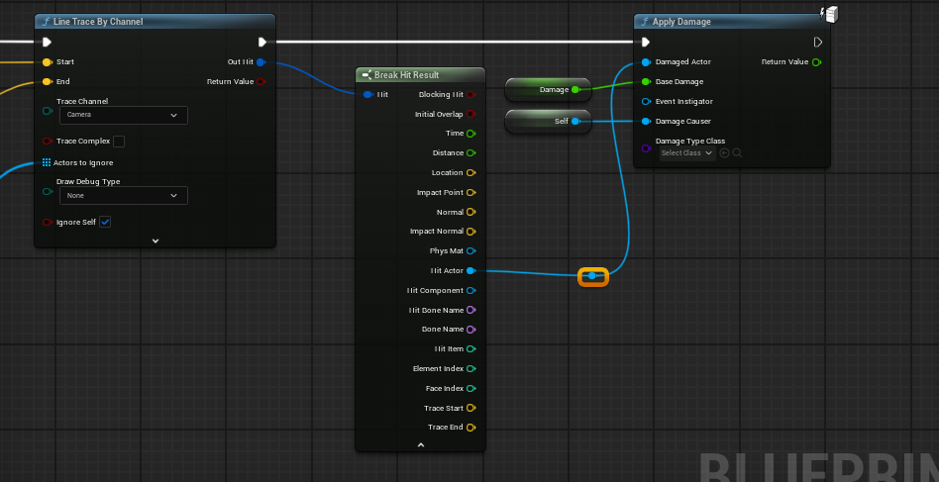
- Drag out from the Out Hit of the LineTraceByChannel node, search, and create a Break Hit Result node.

- Click the downward arrow at the bottom of the Break Hit Result node to expand it. You can see that a whole lot of information is collected here.

- Use the Hit Actor as the Damaged Actor input of the Apply Damage node. The Damage and self node is created the same way as the pipe, but let’s make the value of the Damage variable 10 instead of 100.

Copy BP here (you will still have to connect it)

Add a sparkle VFX to the hit location.

- In the Fab store in your editor, search for Simple Particle Burst, select the Personal Use license, and add the VFX to your project.

- Open your VFX folder and you can see some VFX assets inside of it. These VFX assets were built with Unreal Engine’s Niagara system. If you’re interested, it takes little effort to find some tutorials about Niagara online.

- Continue after Apply Damage, create a call to Spawn System at Location node, and set the System Template to NS_Simple_Burst.

- The Location of the Break Hit Result goes to the Location input.

- Drag out from the Normal of the Break Hit Result and create a Make Rot from X.

- Connect the Return Value of the Make Rot from X node to the Rotation input.

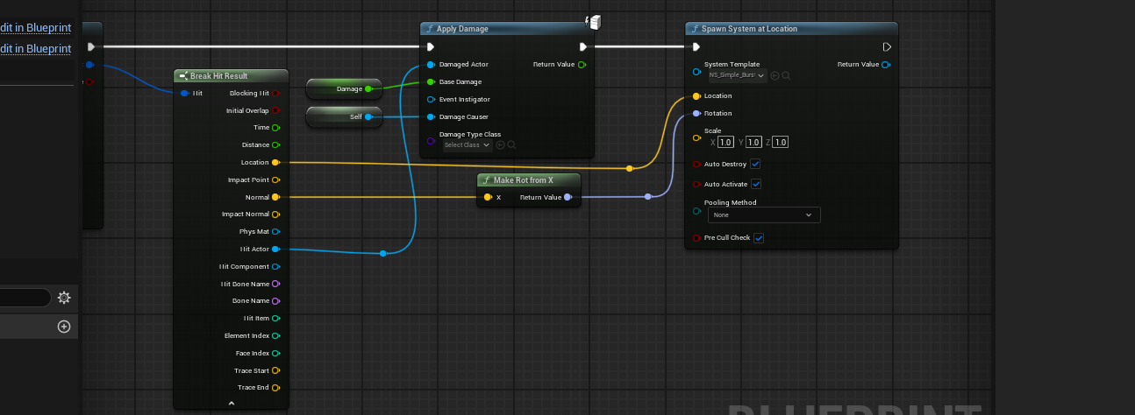

Copy BP here (you’ll still have to connect it)

Set the acquired weapon to BP_Gun, play the game, and test it. A sparkle gets generated at the hit point of the gunshot every time you shoot. You can also shoot the BP_CharacterBase and see the damage printed at the upper left corner of the screen.
PS: To make sure your Niagara effect is only playing once:

- Find and open it (NS_Simple_Burst).

- Select the NS_Simple_Burst node (it’s cyan-colored).

- Search for Loop in the right Details panel.

- Set Loop Behavior to Once.

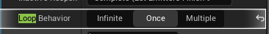

Grenade launcher grenade.

- For the grenade launcher, we need a different approach. It has to throw out an actual grenade. Create a Blueprint class derived from Actor and name it BP_Grenade.

- Add a StaticMesh component to it and set it to a grenade static mesh. There are plenty of free options on Fab.

- Drag the StaticMesh up, overlap it with the DefaultSceneRoot, and release the mouse button to replace the scene root with the StaticMesh.

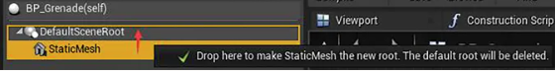

With the StaticMesh selected, go to the Details panel and set the Collision Presets under the Collision section to NoCollision (we don’t want it to collide with the player when it is in the barrel).

Implement an Ignite event.

- Go to the event graph and implement a custom event called Ignite as shown below.

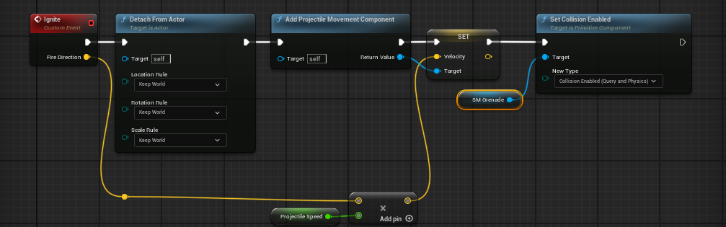

Copy BP here

We want to be able to set the direction of the velocity when calling the function, so we added a Fire Direction input to the Ignite event. We then multiply it with a promoted variable called Projectile Speed to specify the value of the velocity. Set the Projectile Speed variable to 2500.

The yellow Set Velocity node is created by dragging out the Return Value of the Add Projectile Movement Component and searching for Set Velocity.

- Select the Add Projectile Movement Component node.

- Go to the Details panel and check on the Rotation Follows Velocity and Should Bounce. These two settings make the projectile face the direction of its velocity and also enable collision.

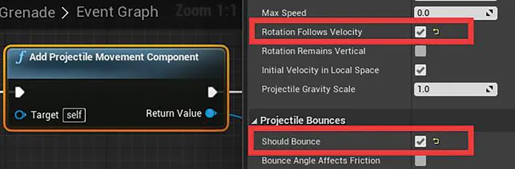

Add an explosion when hit and deal damage.

- With the StaticMesh component selected, go to the Details panel, and scroll down to the bottom to find the Events section.

- Click on the + button on the right of the On Component Hit label to create an On Component Hit (StaticMesh) event.

- This event fires when the StaticMesh hits anything. Implement this event as shown below.

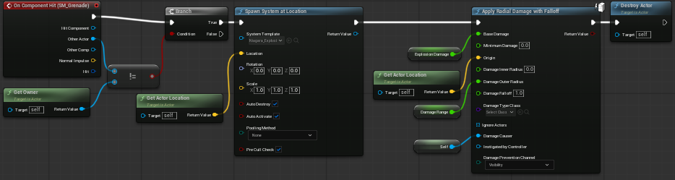

Copy BP here

- Open the Fab window in your editor and search for FREE! Realistic Niagara Explosions Pack and add it to your project.

- Open Niagara_Explosion_03, select the cyan node, and set the Loop Behavior to Once.

- In the above blueprint, we set the System Template to Niagara_Explosion_03 and the Location to be the location of the grenade. This code spawns an explosion VFX at the location of the grenade.

- Next, we call the Apply Radial Damage with Falloff function. This function applies damage with a falloff, and we set the Damage Falloff to 1.

- Explosion Damage and Damage Range are two promoted variables, and their values are both 200.

Set up a grenade launch point socket.

- Open the SM_GrenadeLauncher static mesh.

- Go to the Socket Manager and click on the “+” button to create a new socket; name it GrenadeLaunchPoint.

- Set the Preview Static Mesh to the grenade, move, and rotate it, so it fits into the barrel nicely. This option is under the Advanced dropdown. It may have been removed in 5.6, just do your best to assume where the grenade should be.

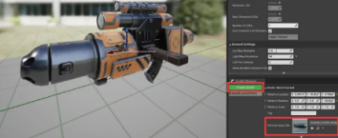

Preload a grenade.

- Open BP_GrenadeLauncher. Implement a function called LoadGrenadeOnSpawn as shown in.

- And call it in the Event BeginPay.

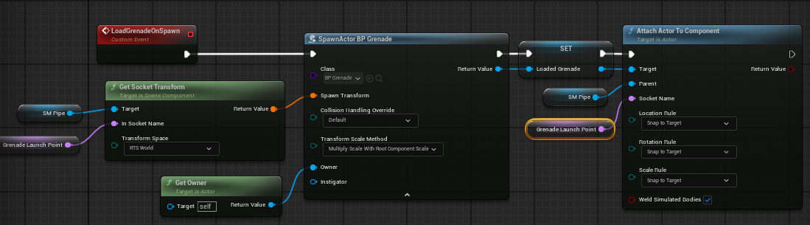

Copy BP here

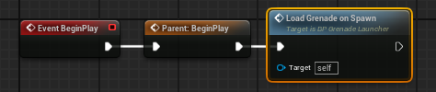

We spawn a BP_Grenade at the GrenadeLaunchPoint socket and notice that we set the Owner to be the owner of the grenade launcher, which should be the BP_CharacterBase that owns this grenade launcher.

Switch the acquired weapon of BP_CharacterBase to BP_GrenadeLauncher, play the game, and you should see that the grenade is already in the barrel.

Shoot the grenade.

Go back to BP_GrenadeLauncher and override the Event Commit Attack Anim Notify as shown below.

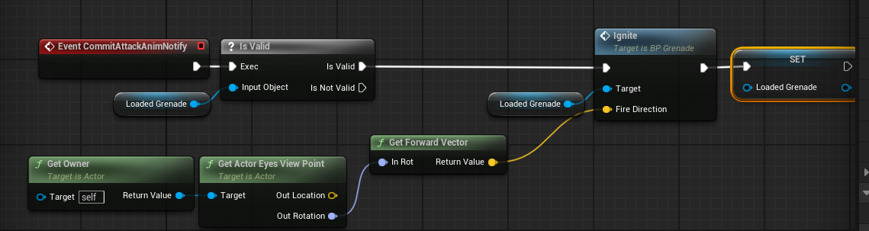

Copy BP here

Play the game again and try to shoot with the grenade launcher. What is cool here is that the printed damage value is different depending on the distance. You can also hurt yourself, which isn’t necessarily a bad thing when it comes to gameplay; we will keep it this way.

Reloading
Create a BP_RangedWeapon class.

- Create a new class called BP_RangedWeapon derived from BP_WeaponBase (Create it as a child of BP_WeaponBase).

- Open BP_Gun, click on the Class Settings button in the toolbar, go to the Details panel, and set the Parent Class to BP_RangedWeapon.

- Do the same thing to BP_GrenadeLauncher .

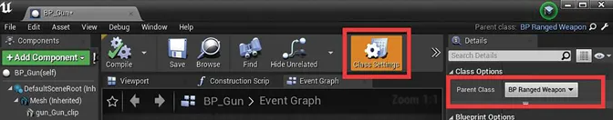

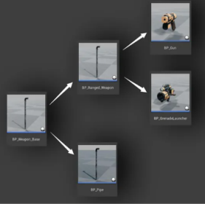
Our class hierarchy has changed a little bit as shown to the right:

Add variables for the ammo.

- Add three variables to BP_RangedWeapon. AmmoInInventory, AmmoInClip, and ClipCapacity.

- Make their variable-type integer.

Override Can Attack.

- In BP_RangedWeapon, go to the functions and override the Can Attack function. Unreal created a new function for us with the same name and already added a call to the parent function.

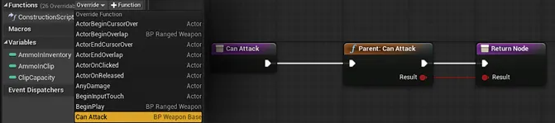

Copy BP here

Implement the Can Attack function.

- Hold down Ctrl and drag the AmmoInClip to the graph, drag out from it, search for “ > ,” and create a greater than node.

- Drag out from the Result of the Parent: Can Attack function, create an AND Boolean, and connect the output pin of the > node to the second input of the AND Boolean node.

- Finally, the output pin of the AND Boolean goes to the Result of the Return Node.

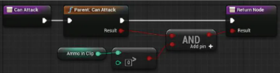

Copy entire updated BP here

What we did here is to ensure that two things have to be true to allow attack. First of all, AmmoInClip has to be bigger than 0, or in other words, there is ammo in clip; second, whatever the parent function has to ensure.

Implement DecreaseAmmoInClip.

- In the Event Graph, create a new custom event, call it DecreaseAmmoInClip, and implement it as shown.

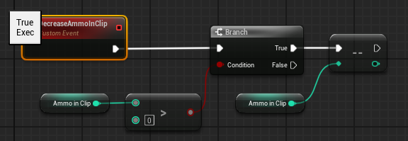

Copy BP here

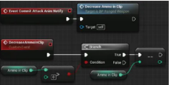
The logic here is straightforward. If there is ammo in the clip, remove one. The last node is called a decrement node, and you can create it by dragging out from Ammo in Clip and search with 2 “−” (minus) characters. What decrement does is set the value of the input to input − 1.

Override CommitAttackAnimNotify.

- We should only decrease ammo when the attack is committed in the animation. Override CommitAttackAnimNotify and call DecreaseAmmoInClip with it.

Add parent call to CommitAttackAnimNotify in the child class.

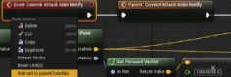
- Open BP_Gun and find its CommitAttackAnimNotify. Right click on Event CommitAttackAnimNotify and select Add call to parent function. It may already be there, but it’s still good to know how to do this.

- A Parent: Commit Attack Anim Notify was added, and insert it at the beginning of Event CommitAttackAnimNotify (as shown).

- Do the same thing to the BP_GrenadeLauncher.

Try to play again, and we cannot fire anymore. This is because the ammo is 0 by default.

Create an UpdateUI event.

- We don’t have a UI yet, but it does not prevent us from creating one and implementing it properly later. Add an empty custom event called UpdateUI to BP_WeaponBase. Do this yourself.

- Go to BP_RangedWeapon and override the UpdateUI event. For now, let’s make a call to Print String.

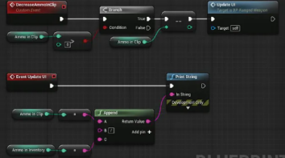
- Drag out the In String of the Print String node, search, and create an Append node.

- Add a new pin to the Append node.

- Hold down Ctrl and drag the AmmoInClip and the AmmoInInventory to the graph.

- Connect AmmoInClip to the input A of the Append node.

- Connect AmmoInInventory to the Input C of the Append node. Type in “/” for input B. This will print out AmmoInClip/AmmoInInventory for us, so we can quickly check the ammo count.

- Add a call to UpdateUI at the end of DecreaseAmmoInClip.

Copy BP here (add the Update UI call at the end of the DecreaseAmmoInClip yourself)

Set up the ammo variables.

- Open BP_Gun and click the Class Defaults button in the toolbar.

- Set the Ammo in Inventory, Ammo in Clip, and Clip Capacity all to 5.

- For the BP_GrenadeLauncher, set the Ammo in Inventory to 3 and set both the Ammo in Clip and Clip Capacity to 1.

- Play the game again, and try to shoot. You can now see the ammo count was printed, and you can no longer shoot if you have no ammo left in the clip.

Create the Reload events and CanReload function.

- The Events and functions of the reloading part are similar to the attacking. We need a Reload event, a CanReload function, and a PlayReloadAM event. But we need more notify events.

- Open BP_WeaponBase and implement a CanReload function, and implement it in the Event Graph as shown.

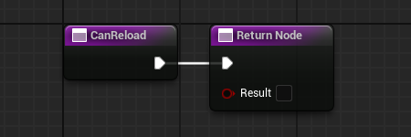
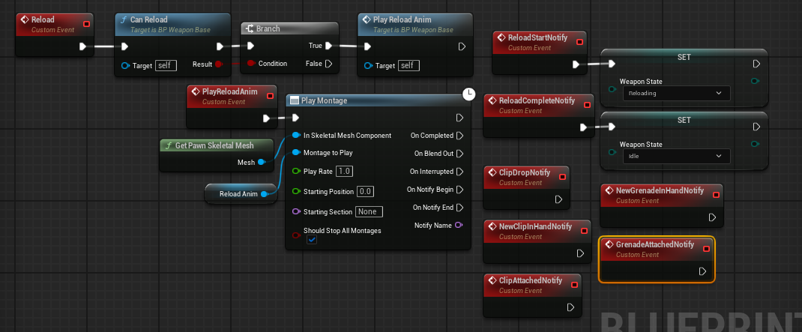

Copy Notify Events here

For the Can Reload function, we simply make it return a false in BP_WeaponBase (some of the weapons do not need to be reloaded). The ReloadAnim is a new variable of the type Anim Montage, the same type as AttackAnim.

Make sure you set the Weapon State dropdown to Reloading in the first Set Weapon State, as shown in the above image.

You also might have to delete and remake the PlayReloadAnim node (if you copy/pasted).

Create the reloading animation montage for the gun.

- Go to the animations folder, and add a reloading animation named AS_Reloading, from Mixamo or otherwise, and create an AnimMontage with it.

- Open the new AnimMontage, make sure the preview mesh in hand is the gun, and add the following new notifies:

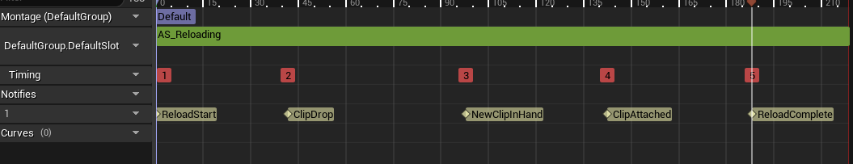

ReloadStart: Positioned at the beginning of the animation.

ClipDrop: Positioned at the time the empty clip drops out.

NewClipInHand: Positioned at the time that the animation has a new clip added to the left hand (in Maya).

ClipAttached: Positioned at the time when the clip is pushed into the gun.

ReloadComplete: At the time when the hands settle down, we think that the player can attack again.

Add the sockets for the clip and the grenade.

- Go to the Skeleton button (light blue top-right button) to switch to the skeleton. Let’s add two more sockets for the grenade and the clip of the gun and name them GrenadeHandSocket and ClipHandSocket. They’ll be attached to the left hand.

- We need these two, so we can attach them when reloading. Don’t forget to remove the attached assets and then attach the asset you need to see to better position the socket.

- And of course, switch to the corresponding reload animations as well.

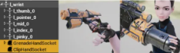

Create the reloading animation montage for the grenade launcher.

- Create the reloading AnimMontage for the grenade launcher reload, and add the following notifies (I’m duplicating my original reload animation, naming it AS_LauncherReload, and turning that into an Animation Montage):

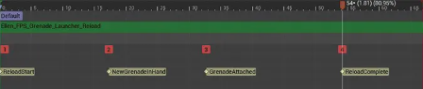

Remember: Make these notifies from scratch, don’t reuse from your other reloading animation.

ReloadStart: This is the same as the gun.

NewGrenadeInHand: Positioned at the time when the new grenade pops into existence in the left hand when the left hand is off screen.

GrenadeAttached: Positioned at the time when the grenade is loaded in the barrel.

ReloadComplete: This is the same as the gun.

Implement notifies in the animation blueprint.

- Go to the event graph of the animation blueprint, and implement all the notifies we added in the animation montage here. They are all implemented the same way as the AnimNotify_CommitAttack.

- Get the pawn owner, cast it to BP_CharacterBase, get the active weapon, and call the corresponding event we added before.

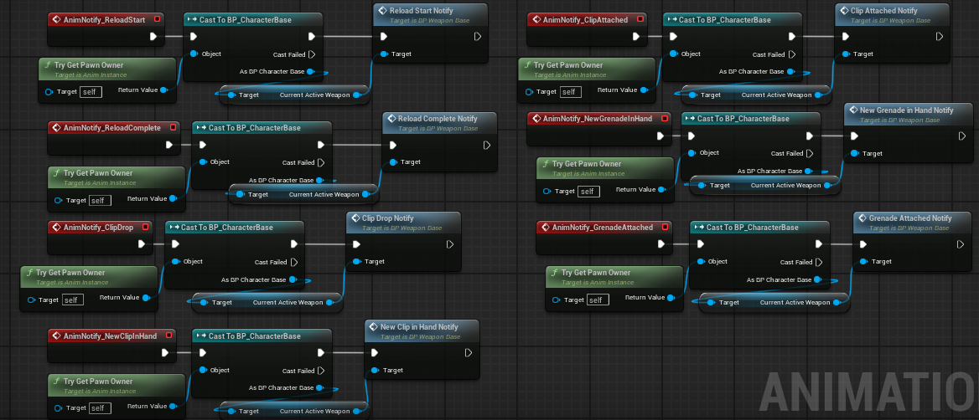

Copy BP here

Now all our weapons can receive these notifies if they override these events.

Assign the corresponding reload Animation montage to the weapons.

- The ReloadAnim variables are still empty in BP_Gun and BP_GrenadeLauncher.

- Assign the animation montages we just created to them in the Class Default settings.

Set up the reload input and Implement the event in BP_CharacterFPS.

- Duplicate your IA_Jump input action and rename it to IA_Reload.

- Open your IMC_Default map controls in the ThirdPerson folder and add another control, and set it to IA_Reload. Change the key to R.

- Go to the event graph of BP_CharacterFPS, search and create an EnhancedInputAction IA_Reload.

- Implement the InputAction Reload as shown.

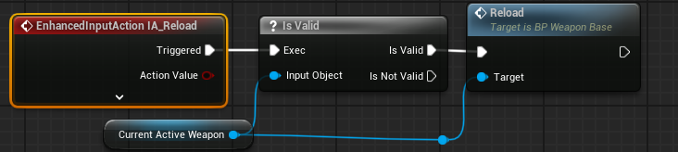

Implement CanReload.

- Open BP_RangedWeapon and override the CanReload function as shown.

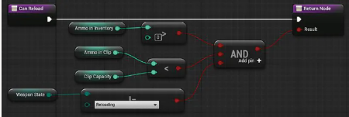
Copy BP here

Note: Make sure your dropdown is set to Reloading here if you copy/paste.

We are checking three things here.

- First of all, is there any ammo left in the inventory?

- Second, AmmoInClip has to be smaller than ClipCapacity (otherwise, the clip is full, no need to reload).

- Finally, the weapon state should not be reloading (we don’t want to reload again 606 when we are already reloading). All three have to be true for the AND Boolean to return true.

Play the game again, and our reloading should be half-working.

- The ammo reduces as expected when we shoot, and we can reload by pressing R if the clip is not full.

- We cannot reload or even shoot during reloading.

- However, the most important thing is not done; the ammo in the clip should replenish.

Implement MoveAmmoToFillClip.

- Create a new custom event to BP_RangedWeapon and call it MoveAmmoToFillClip. Implement it as shown.

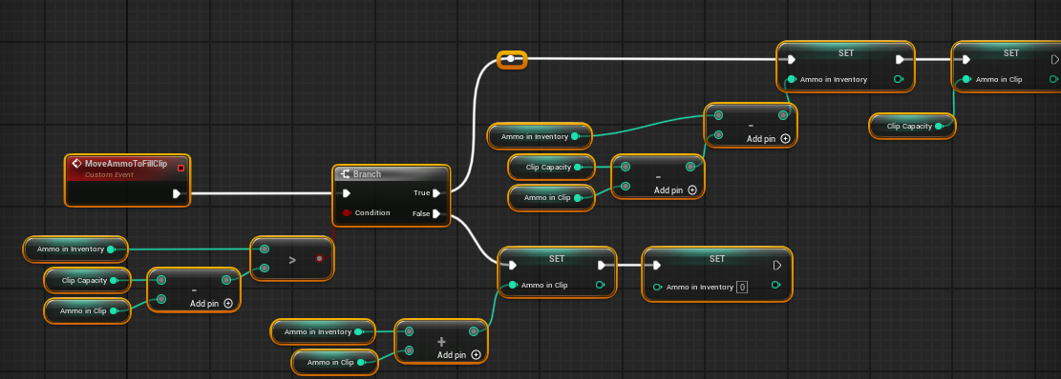

Copy BP here

If there is enough in the inventory (True), we take out the number of ammo needed from AmmonInInventory by setting AmmonInInventory as AmmonInInventory − (ClipCapacity − AmmoInClip). And then, we set the AmmoInClip to the ClipCapacity to make the clip full . If there is not enough, we add what’s left in the AmmoInInventory to the AmmoInClip and set the AmmoInInventory to empty.

Call MoveAmmoToFillClip in ReloadCompleteNotify.

- Create an override of ReloadCompleteNotify, add a call to its parent function first (by right-clicking), then call MoveAmmoToFillClip, and then add a call to UpdateUI as well.

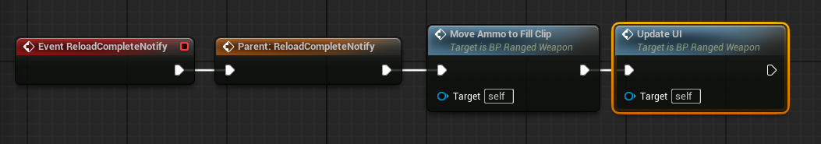

Copy BP here

Play the game now, and the gun should work already, you can try to reload, and it reloads and prints out the numbers nicely. The grenade launcher reloads and does update the numbers. However, there is no new grenade to fire out after the first one goes out.

Spawn new grenade.

- Open BP_GrenadeLauncher, override the GrenadeInHandNotify event, and implement it as shown.

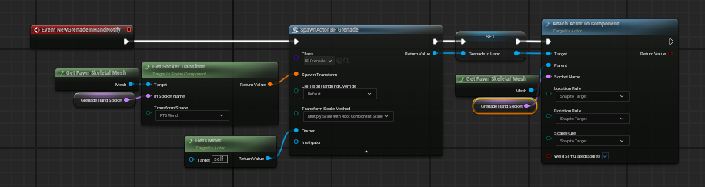

Copy BP here

You’ll have to create a GrenadeHandSocket variable with the same value as its name, and a GrenadeInHand variable of type object reference.

Attach the new grenade to the GrenadeLaunchPoint when notified.

- Override the GrenadeAttachedNotify event and implement it as shown.

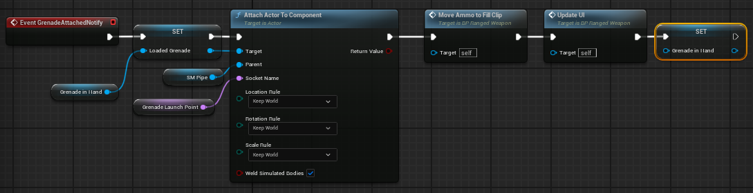

Copy BP Here

Tip: Switch the location rule dropdowns to SnapToTarget in the AttachActorToComponent node.

Play the game now, and the grenade launcher should have a completely working reload functionality.

Create a clip actor that automatically drops.

- Create a new blueprint class derived from Actor. Name it BP_GunClipDrop and double click to open it.

- Add a static mesh component to it and set the mesh to your gun clip (SM_GunClip). I’m using the bullet static mesh as a placeholder.

- Under the Physics section of the Details panel, check on Simulate Physics.

- Set the Collision Presets in the Collision section to Custom, expand it, and set all responses to Ignore.

- Go to its event graph, add a call to the Delay function in Event BeginPlay, and set the Duration to 2.

- Add a call to DestroyActor after the Delay node (as shown). This setup makes it self-destruct after 2 seconds.

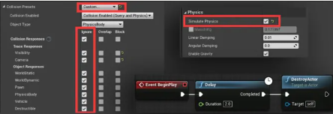

Override the ClipDropNotify event.

- Go to BP_Gun, and drag your bullet static mesh in the Components panel over your gun clip static mesh to parent it under the gun clip.

- Override the ClipDropNotify event and implement it as shown.

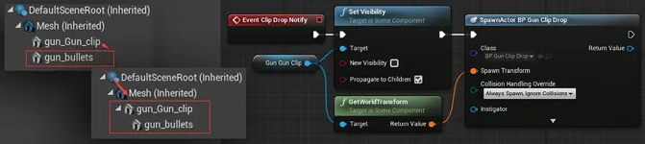

Copy BP here

Create a BP_GunClipFull class.

- Create another blueprint class derived from Actor. Name it BP_GunClipFull, and open it.

- Add two static mesh components to it: make one of them the static mesh for your bullets and another one the static mesh for your gun clip.

- Set the collision presets of both components to NoCollision. We just need them to be the visual of the new clip during the animation.

Override the NewClipInHandNotify.

- Override the NewClipInHandNotify event in BP_Gun as shown.

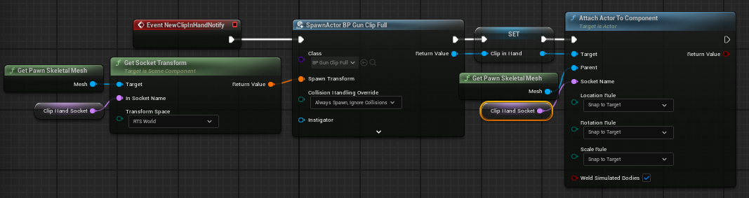

Copy BP Here

What we do here is to spawn a BP_GunClipFull and attach it to the ClipHandSocket. We also promoted it to a new variable called ClipInHand.

Override the ClipAttachedNotify.

- Override the ClipAttachedNotify event in BP_Gun as shown.

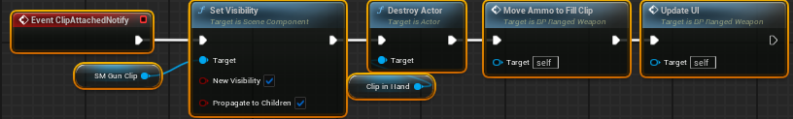

Copy BP here

Refactor Reload and Attack to BP_CharacterBase.

- Go to BP_CharacterBase and implement an Attack and a Reload custom event there; each of them just gets the CurrentActiveWeapon, and checks if it is valid and then does Attack and Reload.

- Go to BP_CharacterFPS and modify InputAction Fire and InputAction Reload to call the Attack and Reload event we just created.

BP_CharacterBase: | BP_CharacterFPS:
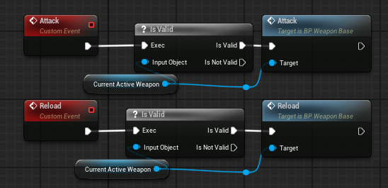 | 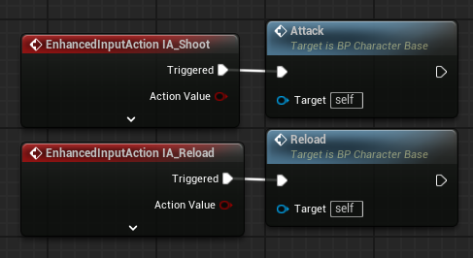
Copy BP for BP_CharacterBase here

Note: Make sure you pull out of the CurrentActiveWeapon variable to create the blue Attack and Reload custom events. We do this to give our system more scalability. If we want the AI to attack, they can also call the Attack event.

Auto reload. It would be strange if the character does not automatically reload when there is no ammo in the clip anymore.

- Go to BP_RangedWeapon, and add a new custom event called AutoReloadIfClipIsEmpty. Implement it as shown.

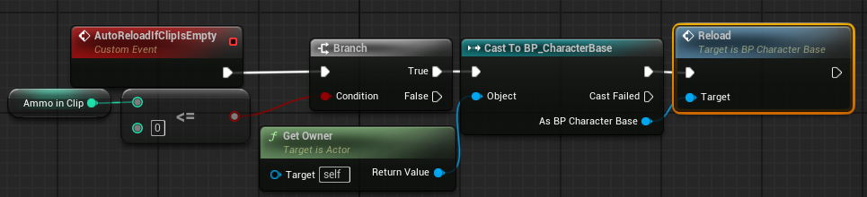

Copy BP here

Note: Make sure the Reload target is BP_CharacterBase. It can be simply read as: if there is no ammo in the clip, ask the owner to reload.

Call AutoReloadIfClipIsEmpty in Event Commit Attack Anim Notify.

- Find the Event Commit Attack Anim Notify in BP_RangedWeapon, and add a call to AutoReloadIfClipIsEmpty at the end of the event.

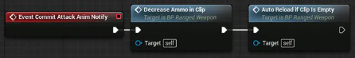

Copy BP here

There is, however, a little bug in our current setup. Try playing the game with the gun and keep spamming the R button and the left mouse button. And you will see that there is a chance for the gun to fire after you start reloading.

There is a chance that the reloading is triggered just when the attack animation is about to reach Received_NotifyEnd. Because two animation montages are blending, animation notifies in both animation montages can all be triggered.

Add state check to ANS_WeaponAttack.

- Open ANS_WeaponAttack. And go to the Received_NotifyEnd function.

- Modify it to the one shown.

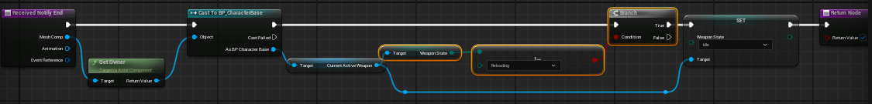

Copy BP here

What we added here are the nodes that are selected in the image above. Also note, the Return value is true at the end and the Enum is set to Reloading.

We simply check if the weapon state is Reloading; if the state is not reloading, we can proceed to change it to idle, but if it is reloading, we don’t change it to idle.

Bug

We can undo this connection in BP_CharacterBase, which is causing errors when we click:
